SMART EMERGENCY DRONE FLEET AND MISSION MANAGEMENT SYSTEM
1. Problem Understanding
In flood, wildfire, medical, or any other type of disasters, drones should be deployed quickly and effectively. There are various kinds of drones with their own abilities such as rescue operations, medical deliveries, surveillance, payload, battery level, range, etc. The manual selection of the appropriate drone for each mission may result in inefficiencies, mistakes, and ineffective use of drones.
This project introduces the Smart Emergency Drone Fleet and Mission Management System as an approach towards centralized management of emergency drones and missions. The system stores data on drones such as their specialization, battery level, payload, range, availability, mission allocation.
The system also contains an emergency mission queue storing mission priority, required payload, range, expected time, cost and status. These parameters can be used for intelligent drone allocation for emergency missions.
The project includes both C++ system engine and web interface connected to database. The web interface allows the users to register drones, create missions, check the availability of the fleet, allocate drones automatically, view system events and generate reports.
The project includes the following C++ OOP features:
- Classes and objects
- Constructors and destructors
- Encapsulation
- Inheritance
- Multilevel inheritance
- Multiple inheritance
- Virtual inheritance
- Abstract classes
- Pure virtual functions
- Function overriding
- Runtime polymorphism
- Operator overloading
- Dynamic memory management
- Pointers
- Safe downcasting
- Composition
- Database integration
The proposed system thus includes both academic criteria of CO3 and CO4 along with practical usage in emergency situations.

2. Design Overview
For the proposed system, a C++ based object-oriented approach is utilized where general properties of emergency resources and specialization of drones are shown through the use of a base class and derived classes respectively.
ResourceIdentity is used in this architecture for identity layer. The EmergencyResource class represents the basic resource class with properties and operations that are common for all emergency drones.
Different specialization classes of drones include:
- RescueDrone
- MedicalDrone
- SurveillanceDrone
- AdvancedRescueDrone
- HybridEmergencyDrone
Inheritance is used in this architecture for the representation of capability of drones. Rescue, medical, and surveillance drones represent operational specialization of drones while advanced and hybrid drones show multilevel and multiple inheritance respectively.
The system employs composition to support components like:
- BatteryModule
- NavigationModule
These are related to the emergency resource and not considered drone types.
The system is organized into several areas:
Fleet Management
The Fleet Management component manages the drone fleet and shows:
- Drone ID
- Drone model/callsign
- Drone specialization
- Battery level
- Payload capacity
- Operating range
- Deployment status
Mission Management
The Mission Queue component manages emergency missions and shows:
- Mission ID
- Mission title
- Mission type
- Deployment location
- Emergency priority
- Required payload
- Required range
- Estimated duration
- Estimated cost
- Mission status
- Assigned drone
Smart Auto Allocation
Smart Auto Allocation is tasked with choosing the right drone for an emergency task based on the following:
- Mission type
- Priority
- Required payload
- Required range
- Battery availability
- Drone status
- Drone specialization
Reports and Analytics
Report & Analytics Module provides the following operational details:
- Fleet availability
- Fleet readiness
- Mission queue
- Cost analysis
- Drone utilization
- Battery and sensor information
- CSV export
- Printable reports
System Logs
System Logs keeps record of important activities carried out through the C++ system engine.
Examples of these are:
- Fleet loading
- Mission loading
- Mission creation
- Mission assignment
- Mission activation
- Drone deployment
- Automatic allocation
C++ Engine and Database
The system has its engine coded in C++ and uses SQLite databases to store data related to the fleet and missions.
The web interface interacts with the backend, and the information received is presented in the form of an easy-to-use dashboard.

3. C++ Concepts Used
Object-Oriented Programming
Objects are used to represent drones, missions, resources, and other related modules.
Encapsulation
All drone parameters and functions of the system are represented in the classes, which have appropriate access specifiers.
Constructors
Destructors are used to perform cleanup tasks for drone and resource objects.
Destructors
The constructors are used to initialize the drone and resource objects with the necessary information.
Dynamic Memory
Dynamic memory is employed when there is need for runtime allocation for data objects in the system.
Inheritance
Inheritance comes in different ways in the project:
- Single inheritance
- Hierarchical inheritance
- Multilevel inheritance
- Multiple inheritance
- Virtual inheritance
Polymorphism
Virtual functions and overriding enable the performance of specific tasks by drones using the same interfaces.
Abstract Class
Common emergency resource class provides a generalized interface for different kinds of emergency drones.
Virtual Inheritance
Diamond problem is solved by virtual inheritance.
Operator Overloading
Operator Overloading is done to enable comparison and printing of the Drone/Resource objects and to perform operations between the objects.
Pointers
Pointers of the Base class are employed to handle different derived classes of the drone object.
Dynamic Cast
Dynamic cast can be applied when an operation on a particular derived drone is required to be performed from the pointer of Base class.
Composition
Battery and Navigation capabilities are shown by means of member components that show a “has-a” relation.
Database Connectivity
The C++ engine interfaces with the SQLite database to get fleet data updated.
4. Pseudocode
Main System Pseudocode
START

Start up C++ engine and database

Load drones from the database
Load emergency missions from the database

Display main dashboard

WHILE system is running

Display available modules

IF Fleet Management selected
Display registered drones
Allow new drone registration
Update drone information
END IF

IF Mission Queue selected
Display emergency missions
Allow new mission registration
Show mission priority and requirements
END IF

IF “Smart Auto Allocation” is chosen
Read pending emergency missions
Check available drones
Battery, payload, range, and specialization comparison
Select suitable drone
Assign drone to mission
Update drone status
Record allocation event
END IF

IF Reports selected
Generate fleet availability report
Generate mission report
Generate cost analysis
Generate drone utilization report
Show battery and sensors details
Allow CSV export
END IF

IF System Logs selected
Read system events
Display timestamp
Display severity
Display event type
Display message details
END IF

IF Architecture and SDG chosen
Display C++ class architecture
Display inheritance relationships
Display SDG alignment
END IF

END WHILE

Close database connection

STOP
5. Implementation Details
Task 1 – Fleet Management and Drone Registration
Fleet Management module gives the user the means to manage emergency drones.
Implementation permits registration of the new drone with the following input:
- Drone ID
- Drone Model / Callsign
- Drone Specialization Type
- Battery Level
- Payload Capacity
- Operating Range
Register New Fleet Drone interface screenshot is used to explain how this function works.
For instance, an example of this implementation includes registering a rescue drone where its parameters include 100% battery life, 15 kg carrying weight, and 50 km operating radius.
Once the drone information is entered, it forms part of the fleet and may be used in mission allocation.
Figure: Register New Fleet Drone
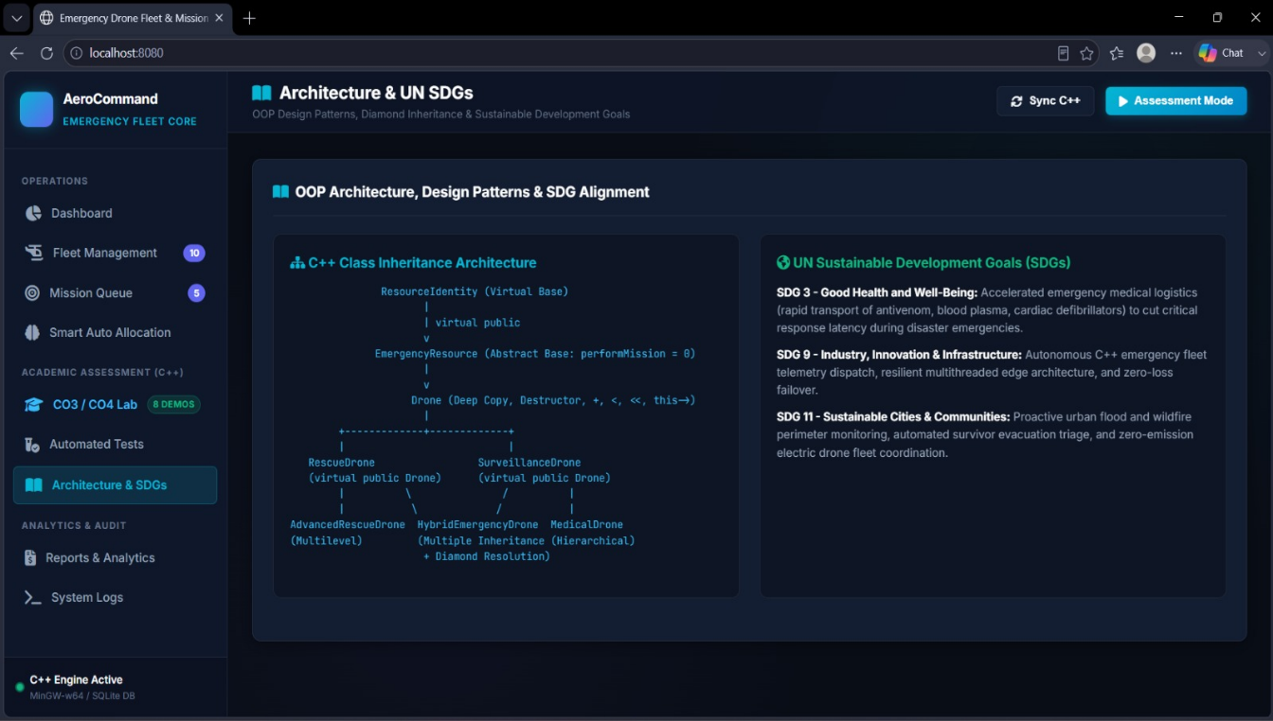

Task 2 – Emergency Mission Registration
There is a dedicated Register Emergency Mission interface for adding new emergency missions.
The user can enter:
- Mission ID
- Mission Title
- Mission Type
- Emergency Priority
- Deployment Location / GPS Coordinates
- Required Payload
- Required Range
- Estimated Duration
For instance, one may generate a critical rescue mission with payload requirements of 8 kg, range of 30 km, and expected time of 1.5 hours.
Upon registering the mission, it is put into the emergency mission queue.
Figure: Register Emergency Mission
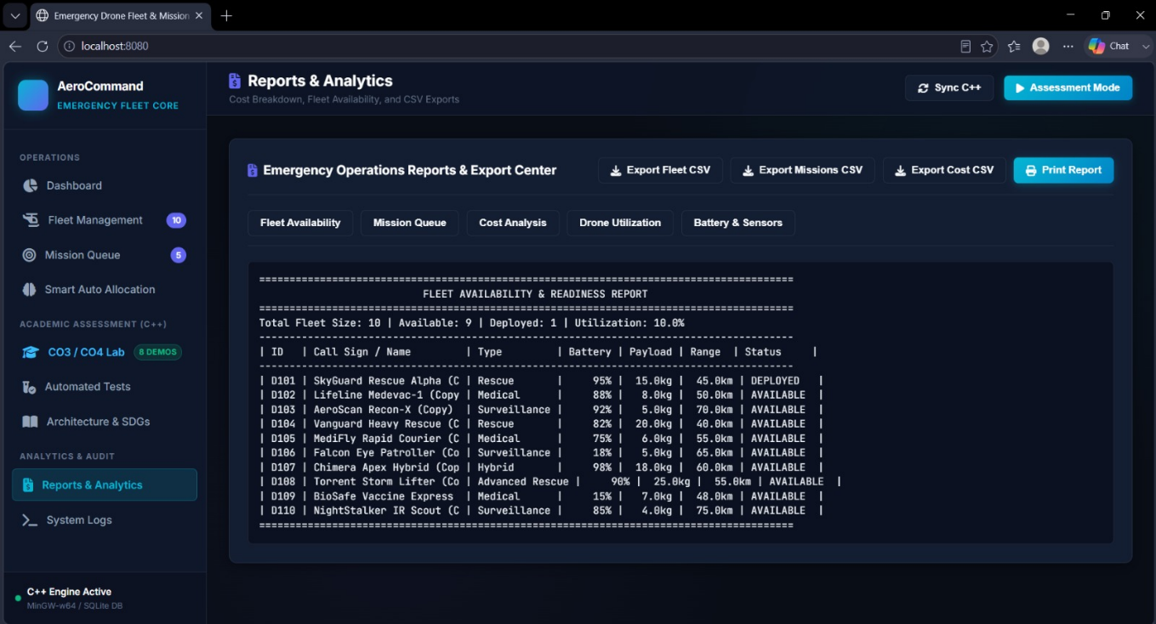

Task 3 – Emergency Mission Queue
Mission Queue displays all the pending and completed emergency missions in detail.
The implementation displays:
- Mission ID
- Mission title
- Mission type
- Location
- Priority
- Required payload
- Required range
- Estimated duration
- Estimated cost
- Mission status
- Assigned drone
There are various priorities such as:
- Critical
- High
- Medium
- Low
The above screenshot contains various instances like evacuation of flood victims, transportation of antivenom, thermal imaging of wildfire, mountain hiker retrieval, first aid for disaster victims, and storm tracking.
This makes sure that the emergency missions can be monitored and prioritized.
Figure: Emergency Mission Queue 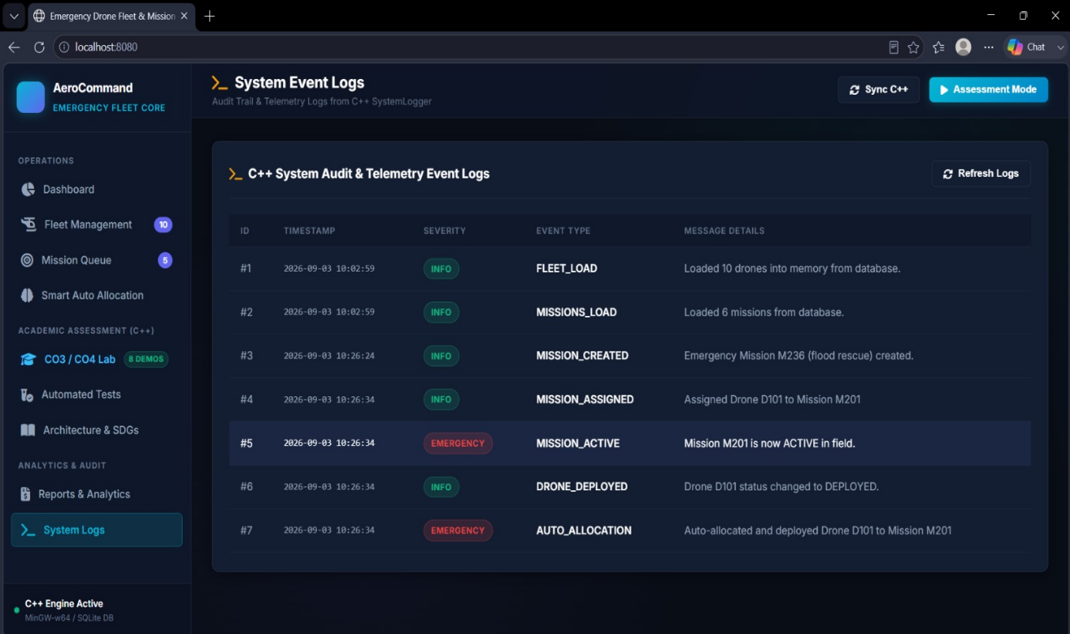

Task 4 – Smart Auto Allocation
The Smart Auto Allocation module is one of the functional modules of the system.
In case of any emergency mission where the requirement of a drone arises, then the system will take into account the fleet resources.
These include:
- Drone availability
- Battery level
- Payload capacity
- Operating range
- Drone specialization
- Mission priority
The appropriate drone will be allocated for the mission.
For instance, there is an automatic allocation process shown in the system log where an unmanned aerial vehicle is allocated and deployed for a particular emergency task.
The system then changes the drone status from "AVAILABLE" to "DEPLOYED" and records the activity in the system event log.

Task 5 – C++ OOP Architecture
The C++ design includes a hierarchical class structure for modeling various types of drones that are used in emergencies.
The base emergency-resource class contains common methods while the derived classes contain specific methods.
This architecture demonstrates:
- Abstraction
- Inheritance
- Hierarchical inheritance
- Multilevel inheritance
- Multiple inheritance
- Virtual inheritance
- Polymorphism
Figure: C++ Class/Inheritance Architecture
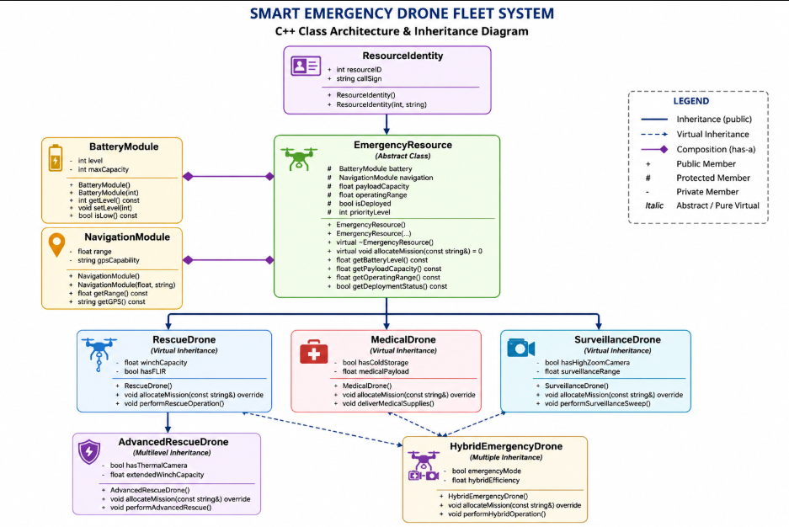

Task 6 – Runtime Polymorphism
Virtual methods are utilized by the system to enable the drones to do specific tasks.
A base class interface may be employed for handling various drones objects.
Conceptually:
C++
EmergencyResource* drone;

drone = new RescueDrone(...);

drone->allocateMission(...);
It depends on the type of the real object rather than just that of the pointer.
This example shows an instance of runtime polymorphism, which enables the system to handle different drones without writing separate processing code for each drone.

Task 7 – Multiple and Virtual Inheritance
The Hybrid Emergency Drone showcases multiple inheritance.
Conceptually:
C++
class HybridEmergencyDrone :
public RescueDrone,
public SurveillanceDrone
{
// Hybrid functionality
};
Because both parents come from the same emergency-resource hierarchy, virtual inheritance is applied to avoid duplication of base class members.
This eliminates the issue of diamonds and assures that a hybrid drone is one physical drone having one identity and common resource data.

Task 8 – Reports and Analytics
The Reports & Analytics module offers operational details of the entire emergency drone fleet.
Fleet Availability and Readiness Report shows:
- Total fleet size
- Available drones
- Deployed drones
- Fleet utilization
- Drone ID
- Callsign
- Drone type
- Battery
- Payload
- Range
- Status
As per the screenshot below, the size of the fleet is 10 drones out of which 9 are available while 1 is deployed, making the utilization as 10.0%.
The module also offers separate sections for:
- Fleet Availability
- Mission Queue
- Cost Analysis
- Drone Utilization
- Battery & Sensors
CSV exports are available for fleet details, missions, and costs as well as Print Report feature is available.
Figure: Emergency Operations Reports & Export Center

Task 9 – System Event Logging
System Logs stores all the system activities performed in audit logs.
Some information stored in the implementation is:
- Event ID
- Timestamp
- Severity
- Event Type
- Message Details
Example of information stored in implementation is:
FLEET_LOAD
MISSIONS_LOAD
MISSION_CREATED
MISSION_ASSIGNED
MISSION_ACTIVE
DRONE_DEPLOYED
AUTO_ALLOCATION
For example:
MISSION_CREATED
Emergency Mission M236 created.

MISSION_ASSIGNED
Assigned Drone D101 to Mission M201.

MISSION_ACTIVE
Mission M201 is active in the field.

DRONE_DEPLOYED
Drone D101 status is now marked as DEPLOYED.

AUTO_ALLOCATION
Auto allocation and deployment of Drone D101 to Mission M201.
This will help keep track of vital emergency missions.
Figure: C++ System Audit & Telemetry Event Logs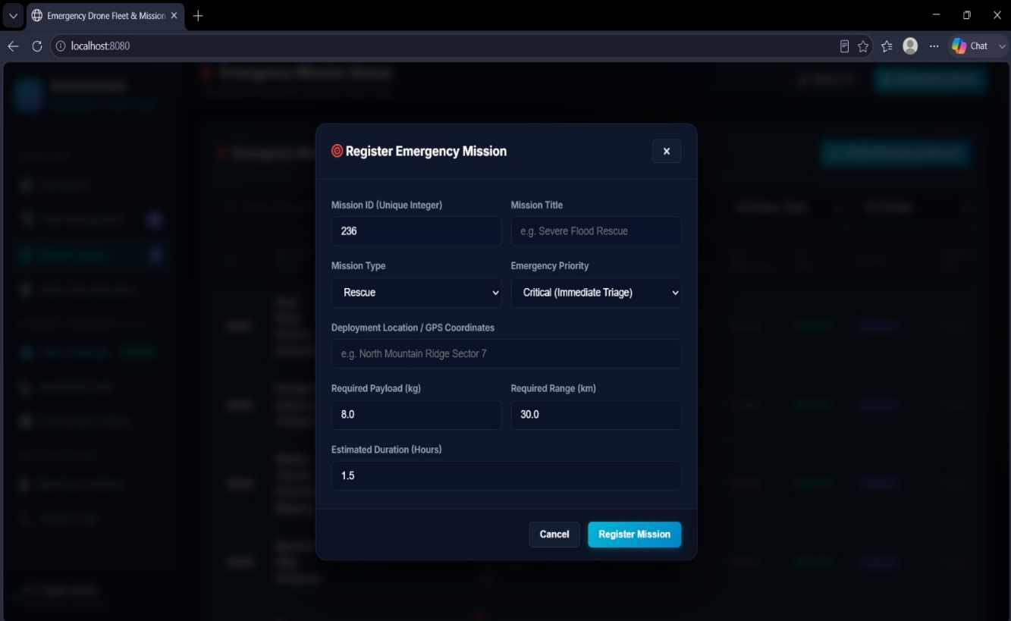
6. Testing
The system was tested with varied operational cases to ensure the functionality of fleet management, mission management, allocation, database, report generation, and logging systems.
Test Case 1 – Drone Registration
A new drone has been added to the Register New Fleet Drone.
All of these information were accepted by the system and the drone was successfully included in the fleet.
Result: Successful.

Test Case 2 – Emergency Mission Registration
An emergency mission was established using the following criteria: Mission ID, mission name, mission type, priority, location, payload, range, and duration.
Outcome: Mission created successfully and added to mission queue.

Test Case 3 – Mission Assignment
An appropriate drone was selected for an upcoming emergency operation.
The status of the mission and the drones used were thus updated.
Result: Successful.

Test Case 4 – Automatic Drone Allocation
The Smart Auto Allocation system analyzed the available drones and allocated a suitable drone for the emergency mission.
The event was also logged into the System Event Logs.
Result: Successful.

Test Case 5 – Drone Deployment
The status of the drone was then changed to DEPLOYED.
This event was then logged by the System Logs module.
Result: Successful.

Test Case 6 – Fleet Report
This report & analytics module was used to create the fleet availability and readiness report.
The report correctly showed the total fleet, available drones, deployed drones, utilization, battery, payload, range, and status.
Result: Successful.

Test Case 7 – System Logging
Critical activities like fleet loading, creating missions, mission assignments, activating missions, deploying missions, and automatic mission assignments were checked using the system logs module.
Result: Successful.

Test Case 8 – Database Synchronization
Sync C++ was used for synchronization of data between the C++ engine and the web application.
Outcome: Data synchronized correctly.

7. Reflection
Design Choices
The main idea was that the common drone properties should be separated from drone-specific behavior.
The common properties like identity, battery, payload, range, and deployment status are managed at the resource level, whereas the drone-specific behavior is implemented by drone classes.
It is also possible to add new drones without changing the whole application due to the possibility to use inheritance.
Composition pattern is used when creating supporting components like the battery and navigation system, as a drone has its own battery and navigation, but it does not belong to batteries or navigation systems.

Object-Oriented Design
It is also nice to see that the theoretical knowledge of C++ language can be applied in practice.
Rather than using individual structures for every drone, the system adopts a uniform object-oriented hierarchy.
This improves:
- Code organization
- Reusability
- Maintainability
- Extensibility
- Runtime flexibility

Smart Allocation
Smart Auto Allocation helps eliminate the need for manually selecting drones in case of emergencies.
This is done after taking into consideration the following constraints: power, payload, range, specialization, and availability.
This helps to ensure that the right drone is assigned.

Database Integration
The use of the C++ engine in conjunction with SQLite ensures persistent storage of the fleet and missions data.
The web interface serves as an easy way of using the core system built using C++, while the database holds the working data.
The combined effect makes this project more realistic than the simple C++ console application.

Monitoring and Logging
The System Logs component generates the audit trail for significant processes.
This is beneficial since emergency systems need information on what took place, when it took place, and which drone or mission it relates to.
The logs will also help make the system more demonstrable and debuggable.

Reports and Analytics
The reporting module allows one to see the state of readiness and operations in the fleet.
Data on fleet utilization, battery capacity, payload, range, costs, and deployment status can allow the operator to analyze the state of the emergency fleet.

SDG Relevance
The project is mostly related to:
SDG 3 – Good Health and Well-Being
The medical drones can be used for rapid delivery of emergency medical supplies, like antivenom.
SDG 9 – Industry, Innovation and Infrastructure
The project shows how the use of C++, databases, automation, and smart resource allocation can be used for creation of an emergency response infrastructure system.
SDG 11 – Sustainable Cities and Communities
Coordination of drones in case of emergencies could help in monitoring the disaster situations, rescue operations, wildfire monitoring, floods, and delivering supplies in emergencies.
Figure: Architecture & UN Sustainable Development Goals
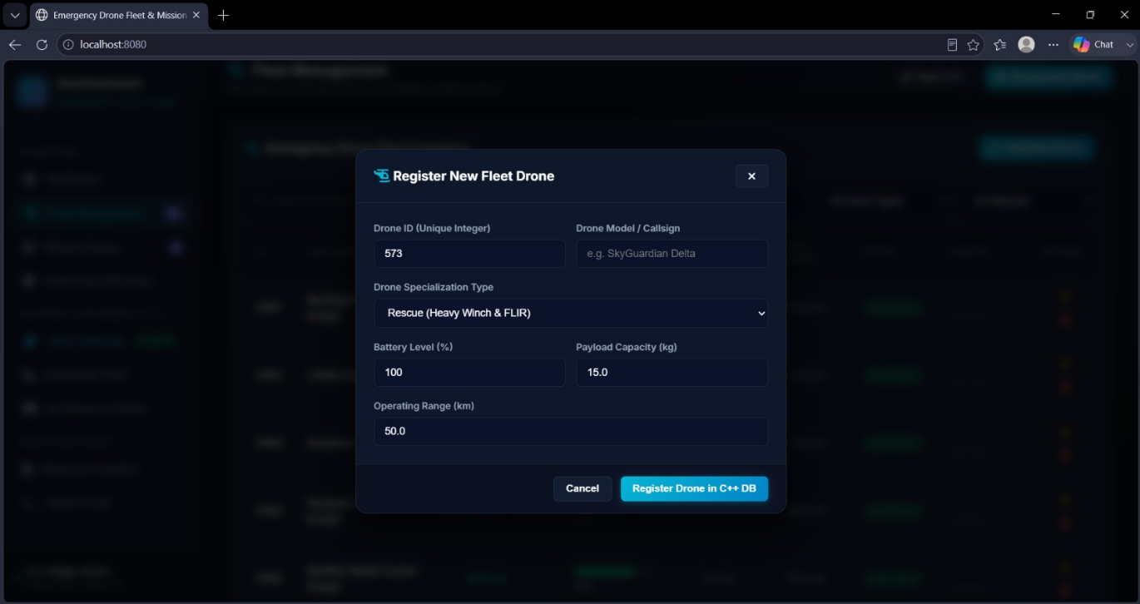
8. GitHub Repository
Repository Link:
[https://github.com/viji243/DSA0106-C-.git]
The code repository includes the source code in C++, database components, web interface, configuration files, and documentation for the project.
9. MAIN DASHBOARD
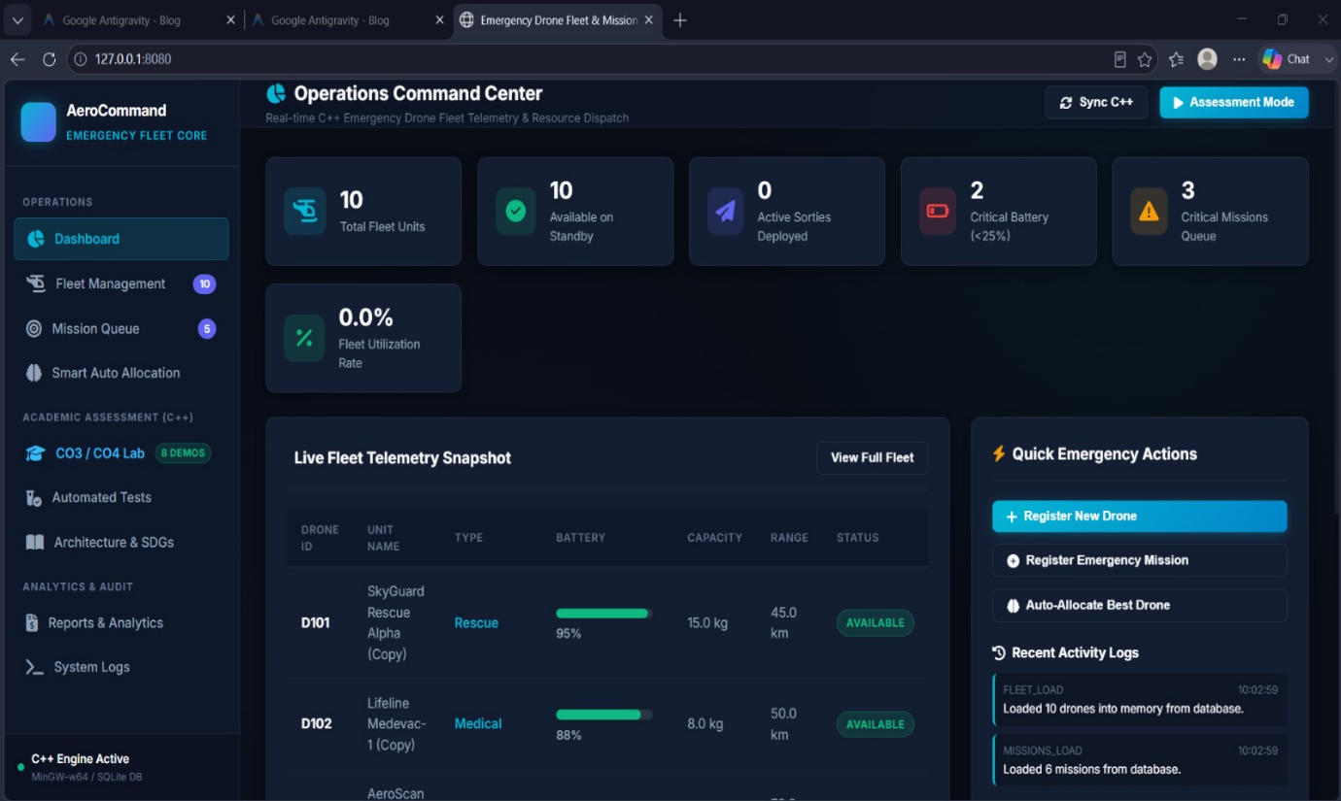

10. One-Page Individual Reflection
Individual Contribution – MEMBER 1
My contributions in this project were focused on system design, fleet management, integration of database, and reports components of Smart Emergency Drone Fleet and Mission Management System. My contribution to this project involved working on the C++ backend design and keeping the basic information related to the emergency drones.
I contributed in handling information related to drones like Drone ID, Model/Callsign, specialization type, battery percentage, payload, range, and deployment status. Another one of my contributions in this project was the Fleet Management module, where registration of the drones was handled and fleet availability and readiness information was displayed.
One of my other contributions in this project was working on the C++ object oriented concepts like classes, constructors, destructors, encapsulation, composition, dynamic memory, and database related components. Contribution in Reports & Analytics module was the display of fleet availability, utilization, battery, payload, range, and drone status.
From the project, I have gained some knowledge about the use of C++ OOP concepts in a practical emergency management system. I also learned how C++ backend can integrate with a database and web interface to give a comprehensive fleet management application.

Individual Contribution – MEMBER 2
For the project, I focused on drone inheritance hierarchy, specialization, polymorphism, and mission management aspects of the Smart Emergency Drone Fleet and Mission Management System.
My contributions to the project included working with various types of drones including Rescue Drone, Medical Drone, Surveillance Drone, Advanced Rescue Drone, and Hybrid Emergency Drone. I helped in implementation of important C++ concepts such as single inheritance, hierarchical inheritance, multilevel inheritance, multiple inheritance, virtual inheritance, abstract classes, pure virtual functions, function overriding, and runtime polymorphism.
In addition to that, I helped in developing the Emergency Mission Queue which is used to maintain emergency missions with information about mission ID, mission type, location, priority, payload required, required range, duration estimate, cost, status, and drone assigned.
The other contribution that I made for the project was development and testing of the Smart Auto Allocation functionality.
Through the course of this project, I got the understanding of how inheritance and polymorphism may be used in a practical application. Moreover, I was able to see how various drone specializations could be modeled using classes in C++.

Individual Contribution – MEMBER 3
My main responsibilities included work on Smart Auto Allocation, system monitoring, logging of system events, testing, and user interface modules of the Smart Emergency Drone Fleet and Mission Management System.
Specifically, I have been working on the Smart Auto Allocation module, which is responsible for finding the proper drone according to mission parameters, such as mission priority, drone specialization, battery, payload capacity, operating range, and drone availability.
Moreover, I worked on System Event Logs module. This system keeps a record of important system events like fleet load, mission load, mission creation, mission assignment, mission activation, drone deployment, and auto allocation, which is helpful in monitoring the operations performed by the system.
Apart from that, I have been testing various system modules and making sure that the web interface correctly reflects the information coming from C++ and database.
This project gave me a clearer picture of system integration, automated allocation of resources, database-driven application, event logging, and testing. This project provided me an insight into how the concepts of C++ programming language could be used along with web interface to make an emergency response management system.

